Phase 2 Source
UMGC CMSC 495 Section 6384
Arora, Neil
Pierce, Holden
Stigall, Michael
Thompson, Kosie

Table of Contents
1 Project Setup
2 Core Functionality
3 Documentation / Implementation of Code
4 Unit Testing
5 Conclusions

Introduction
Phase 2 of the Breakout-style arcade game project builds upon the stable and playable foundation established in Phase I. During this phase, the team transitions from delivering a Minimum Viable Product (MVP) to refining the application into a production-ready implementation. Emphasis is placed on finalizing core gameplay systems, improving modular structure, strengthening state management, expanding unit test coverage, and enhancing documentation quality.
The project continues to use Python and Pygame within a structured and version-controlled environment, ensuring consistency across development machines. Phase 2 focuses on code refactoring, performance stability, and clean architectural separation between gameplay entities, managers, and UI components. Additionally, comprehensive automated testing using pytest supports reliability and regression prevention.
By emphasizing maintainability, scalability, and correctness, Phase 2 prepares the Breakout game for final submission while demonstrating mastery of software development best practices, including structured design, collaborative workflows, testing strategy implementation, and deployment readiness.

1 Project Setup
During Phase 2, the project setup was re-evaluated and finalized to ensure consistency, maintainability, and production readiness. Development continues to be conducted using Visual Studio Code as the primary Integrated Development Environment (IDE), configured with the appropriate Python extensions to support linting, debugging, and streamlined execution. The project environment is standardized according to the Python and Pygame versions documented in the ReadMe file to ensure compatibility across all team members’ machines.
The Pygame library remains the primary framework responsible for rendering, input handling, and real-time game loop management. Automated testing continues to utilize the pytest framework to validate non-graphical components and ensure regression prevention. All required dependencies and setup instructions are clearly documented in the repository’s ReadMe to enable reproducibility of the development environment.

1.1 Configuration Centralization
To improve maintainability and reduce code duplication, the project centralizes configuration constants within the Core/config.py module. This file defines shared values such as screen dimensions, frame rate (FPS), paddle speed, ball speed, scoring values, and default life counts. Gameplay entities including Ball, Paddle, Level, and UI systems import these constants rather than hardcoding values locally.
Centralizing configuration ensures consistent behavior across modules and allows gameplay tuning or display adjustments to be performed from a single location. This approach reduces the risk of conflicting values, simplifies debugging, and supports scalability as additional features are implemented in Phase 2.

1.2 Version Control Workflow
The project repository is maintained using Git and hosted on GitHub. For this capstone implementation, the team follows a disciplined single-branch workflow using the main branch. Although feature branching is available, the team elected to use a controlled main-branch approach due to the project’s scale and team size.
Before committing updates to the repository, team members are expected to:
- Run the full pytest suite to confirm all automated tests pass
- Perform smoke testing to validate gameplay stability (launch, paddle movement, ball collision, block destruction)
- Verify no regressions or runtime errors occur
The repository includes a properly configured .gitignore file to exclude Python cache files, IDE configurations, and temporary artifacts. This ensures the repository remains clean and focused on source code, assets, and documentation.

1.3 Project Structure Verification
During Phase 2, the project directory structure was reviewed and confirmed to support modular architecture and separation of concerns. The structure clearly separates gameplay objects, managers, UI components, configuration files, tests, and assets. This organization improves readability, simplifies debugging, and supports future enhancements such as additional levels, expanded UI systems, and advanced state management.
By finalizing the development environment, configuration management, repository workflow, and project structure, Phase 2 establishes a stable and production-ready foundation for completing core functionality and preparing the Breakout game for final submission.

2 Core Functionality
This section describes the core functional elements of the Breakout game implementation during Phase 2 of the project. Phase 1 focused on establishing a stable and playable foundation of the Breakout-style game by implementing essential gameplay mechanics, algorithms, and modular components. Now in Phase 2 we have moved from that base configuration and reached a stable MVP with some stretch goals, demonstrating a playable game with multiple levels, maintainable structure and extensibility to build on for future phases.

2.1 Implementation Features
Phase 1 implementation focused on foundational gameplay mechanics and systems required for a playable experience. The core implementation relied on establishing collision subsystems, ball, block and paddle mechanics. Special care was taken to maintain smooth movement and ensure consistent play experience.
In phase 2 the implementation moved beyond the basics to refine overall play and break down core mechanics into manager subsystems. The manager subsystems represent the collision manager, game state, input manager and score manager. The audio manager is there but is currently a stretch goal and has no implementation.
The collision manager provides helper functions and manages all aspects of collision within the game. Specifically, it verifies whether the ball hits an object such as a wall, block, or paddle, and calculates the angle to establish the new velocity and vector for the ball.
The game state is used to maintain and track the current game state; whether we are at the main screen, playing the game, at the game over screen, and others which can be extended as needed. The input manager leverages the game state to figure out what an input means on different screens. For example, with the game going the user can press ‘p’ to enter a pause game state, or the left and right arrows to move the paddle, whereas on the main menu screen the up and down arrows can be used to select whether to start a game or exit.
Lastly, the score manager is used to track the current user score and supply that value as needed, such as at the game over screen. Currently the game does not track a high score list, but if time allows the score manager would save that in some way and read from that storage to provide a list of previous scores.
These phase 2 features in combination with the phase 1 features represent the complete MVP, with some reach goals enabled. During the next phase the team will be focused on testing, developing a comprehensive user guide, and adding some stretch goals as time allows.

2.2 Choice of Algorithms
The algorithms selected for Phase 2 prioritize simplicity, like Phase 1. Specifically focused on determinism and clarity to support both gameplay consistency and maintainability.
Collision is calculated by using basic vector arithmetic, where position updates are computed as a function of velocity and delta time. Collision detection uses axis-aligned bounding box (AABB) comparisons to determine intersections between the ball and other game objects, such as blocks and the paddle. Collision response is implemented by inverting the appropriate component of the velocity vector depending on the collision surface.
Block management within a level is supported by a simple collection-based algorithm. The Level class maintains a collection of active blocks and updates the collection as blocks are destroyed. Level completion is determined by checking whether all destructible blocks have been destroyed, triggering either level completion logic or game termination depending on the current scope.
Scoring and life management use simple counter-based algorithms. Block destruction triggers immediate score updates, while life loss events decrement a life counter and reset the ball state. These algorithms are computationally lightweight and well suited to a real-time 2D arcade game.
Game state is tracked as a state machine. Global variables are used to let the game know what state it is presently in, such as the pause state or main menu state, and the input manager decides which inputs should be allowed based on the game state. This simple algorithm ensures that each state works as expected, without adding over complicated tracking of screens or attempting to figure things out by reading the screen buffer.
Use of the chosen algorithms reflects the team’s desire to create a faithful reconstruction of the classic Breakout arcade game. Each algorithm is similar, if not the same, as the original game and ensures the game will behave as the user expects it should.

2.3 Modular Components
During Phase 2 implementation modular design was improved, moving code which was within the main game loop, into a series of managers. By migrating this code into management architecture, it allows for a more complex and better designed game which can be more easily extended in the future.
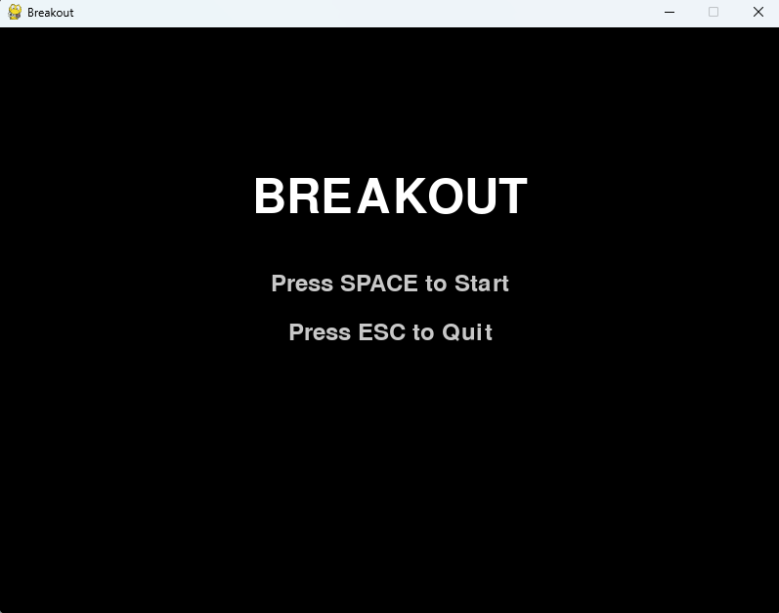
Main Screen: example of a new game state made possible by the new management subsystem
Game state and the input manager are the best examples of how modular design allows for easy extensibility. During early gameplay testing, as levels were being added, it was discovered that attempting to play the last level was tedious because it required completing all previous levels. To speed up testing a new game state was added which allows the user to progress to a ‘level select’ game state, whereby the user can select which level to start from. The game state mechanic allowed this to be easily added, and in the future could allow for this screen to be reached by entering a secret key sequence or developer code from select screens.
Game flow is still managed by a central game loop; however, input handling, collision checks and game state updates are now managed by their respective managers. Additionally, all support systems, such as score tracking, were moved into their own managers to further simplify the code within the main game loop.
Modular design allowed the team to come together and utilize a minimalist design philosophy within the main game loop. By removing complexity into the managers, debugging and fixing bugs becomes easier, and it further enables unit testing of individual components, making it that much easier to add new features without breaking the project in the future.

3 Documentation / Impelmentation of Code
This section describes the documentation practices and implementation standards used throughout Phase 2 of the project. Our team prioritized readability, consistency, and maintainability to ensure that all contributors could easily understand and extend the codebase. Each module follows a clear organizational structure, and classes are designed to encapsulate individual gameplay responsibilities.
Inline comments are used to clarify non-obvious logic, particularly within collision handling, movement updates, and level loading. Method names and variable names were selected to be descriptive and consistent across modules. Configuration values such as screen dimensions, movement speeds, and default object sizes are centralized in the Core configuration files, reducing duplication and simplifying future tuning.
External documentation is provided through the project’s ReadMe.md file, which outlines installation steps, required dependencies, and instructions for running both the game and automated unit tests. This ensures that new contributors can quickly configure their development environment and verify functionality.
The implementation emphasizes modular design by separating gameplay entities (Ball, Paddle, Block, Level) from supporting systems such as input handling, collision management, and scoring. This structure improves maintainability and enables incremental development in later phases.

Example of Comments
Code comments are used to explain key logic and document intended behavior. For example, within the Block class, comments describe the purpose of each method and clarify how damage is applied to blocks during gameplay. Similar documentation exists within the Ball and Paddle classes to explain movement calculations and collision boundaries.
Concise inline comments accompany critical sections such as collision detection, velocity updates, and level loading, ensuring that future contributors can quickly understand how each subsystem operates.
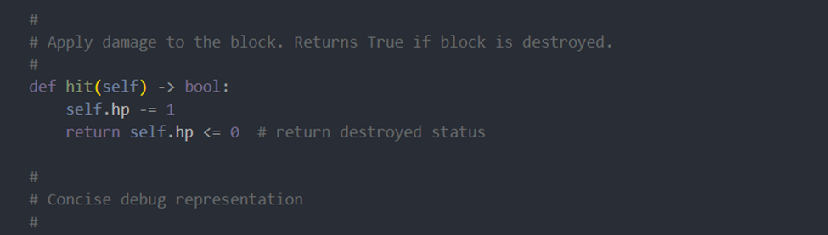
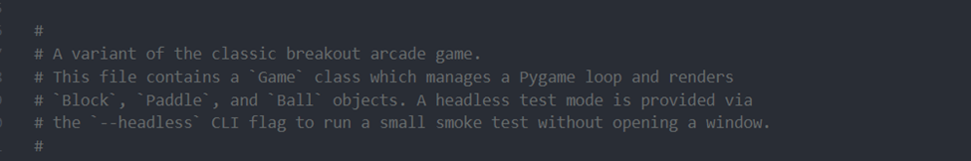
Example of code and comments around that code

Example of Smoke Tests
We performed basic smoke testing by launching the game and verifying that essential gameplay mechanics functioned correctly. Functions such as the following: paddle movement, ball physics, block collisions, score updates, and life loss behavior. These manual checks confirm that the application starts successfully and that the primary gameplay loop operates as expected.
In addition to manual smoke testing, automated unit tests were introduced early in development to validate core object behavior independently of the full game loop. This includes tests for Block initialization, hit logic, and bounding rectangle generation. These tests help detect regressions quickly and provide confidence that core gameplay components remain stable as development continues.

4 Unit Testing
Unit testing was extended in Phase 2 to also include testing of the new manager code, and confirms that main game modules all work correctly on their own before running the full game. The team utilized previously created tests for core gameplay objects (Ball, Paddle, Block and Level) and extended that to also include collision manager, input manager and score manager.

4.1 Major Functionality to Test
The unit tests focus on the main gameplay behaviors which are most important to the Breakout game.
Ball (direction, movement, hitbox)
- Confirms the ball correctly scales the direction values (vx, vy) into a consistent direction.
- Confirms the ball does not get stuck when initialized with no direction (vx=0, vy=0).
- Confirms update(dt) moves the ball the correct distance over time.
- Confirms rect() returns the correct collision box around the ball.
Paddle (movement, boundaries, hitbox)
- Confirms paddle movement updates x correctly when moving left/right.
- Confirms the paddle cannot move off-screen (clamps at the left and right edges).
- Confirms rect() returns the correct collision box around the paddle.
Block (init, hit logic, hitbox)
- Confirms blocks initialize with correct position/size and settings (hp, score, color, etc.).
- Confirms rect() returns the correct collision box.
- Confirms hit() reduces HP correctly and reports when the block is destroyed.
Level (map loading, validation, conversion)
- Confirms Level.from_file() loads a JSON level file correctly (width, height, tile size, and blocks).
- Confirms invalid level data is handled correctly (ex: negative grid coordinates, invalid JSON, missing file).
- Confirms all level JSON files in the levels/asset’s directory can be loaded and converted into valid Block objects.
Collision Manager
- Wall collisions, cause ball to reverse direction and is constrained when it hits the edges.
- Paddle interaction, only downward-moving balls will trigger a bounce; bounce updates velocity and will position the ball above the paddle.
- Block collisions, detect and handle ball and block overlap, flips velocity appropriately, removes destroyed blocks and reports the score value.
- Void check, returns True when the ball has fallen below the screen height triggering a loss of life.
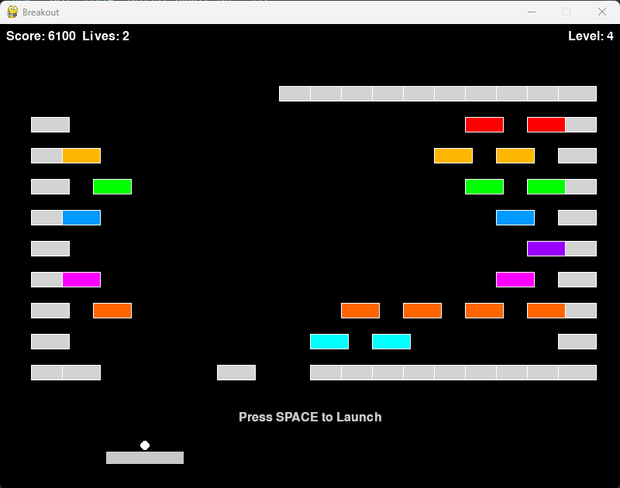
Level 4 after a void out, while waiting for the user to launch to ball
Input Manager
- Launching logic, pressing space launches an unlaunched ball, input is ignored if the ball is already moving and considered launched.
- Movement handling, when in the playing game state, left and right keys move the paddle. A fake input mapping is created to test unexpected key sequences.
- State transitions, handles menu navigation and global quit inputs.
Score Manager
- Level existence and loading, verifies that a level exists by attempting to load the first level and correct populates.
- Level navigation, exercises the next_level and get_available_levels functionality.
- Completion percentage, starts at 0% and changes appropriately as blocks are removed.
- All-levels loader, attempts to load all levels and verify that all of them work.

4.2 Unit Testing Framework
The project uses pytest as the unit testing framework. Pytest was chosen because it runs all tests quickly in one command and gives clear pass/fail results, which makes it easy to verify whether recent code changes have broken previously working features.
All unit tests are stored in the tests/ folder and follow pytest naming conventions:
- Test files start with test_ (ex: test_ball.py, test_paddle.py, etc)
- Test functions start with test_
Using the command: python -m pytest -q tests
Will run all tests and verify whether they have passed successfully or throw errors and warnings. In the case of warnings, the decision can be made to suppress them, such as when using deprecated features of pytest, or to fix them. The team has generally chosen to reach fully ‘green’ status, where all tests reach a full success rate.
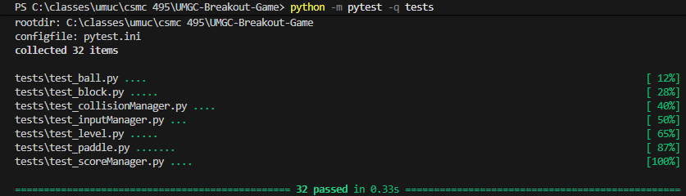
All unit tests running, including the newly added ones.

5 Conclusions
Phase 2 transitions the Breakout game from a functional prototype to a production-ready application. Through the centralization of configuration, the team has established a codebase that is significantly more maintainable and easier to tune. The disciplined version control workflow, combined with rigorous smoke testing prior to each commit, has ensured project stability and prevented regressions as new features were integrated.
The finalization of core features delivers a complete and polished player experience. The implementation of these features using clear and efficient algorithms demonstrates sound software engineering principles. The modular architecture provides a scalable foundation that could easily accommodate future enhancements like power-ups, new block types, or additional visual effects.
Most importantly, Phase 2 has established a benchmark of quality through comprehensive documentation and unit testing. The code is now consistently formatted and commented, with clear docstrings explaining the purpose and logic of key components. By meeting all criteria in the project rubric for documentation, unit testing, and core functionality, Phase 2 has fully prepared the Breakout game for finality and demonstrates a mastery of collaborative software development best practices.

